**Quantifying the Antisaccade Task Performance in Patients with Neurological Disorders**

Michael Popa

Rice University - Houston, TX

NEUR 416, CAAM 416, ELEC 489/589

[map21@rice.edu](mailto:map21@rice.edu)

**Abstract**

The antisaccade task has proven to be a useful tool in getting a more nuanced understanding of various neurological disorders. More specifically, when comparing the performance between patients diagnosed with schizophrenia and a healthy control group, we can see that the schizophrenics have significantly worse results; they have a higher number of errors (erroneous prosaccades), a lower rate of antisaccade corrections, worse latency distributions, and overall higher variability in their performance than the control group. There are two leading theories as to why schizophrenics perform worse: (1) some third top-down inhibitory signal is failing to prevent an erroneous prosaccade from occurring, or (2) there exists competition between the processes guiding the erroneous prosaccade and correct antisaccade decisions. A neural rise-to-threshold model of the superior colliculus is developed to show that a third top-down inhibitory signal is not necessary to explain the performance variability between the groups. The model was successful at reproducing the error rates, as well as all the latency distributions from the experimental data, as opposed to the Noorani and Carpenter (2013) model of the first theory that failed to reproduce the corrected antisaccade latency distributions. The neural rise-to-threshold model was modified and extended beyond just schizophrenia patients to test its performance on reproducing the experimental data for patients with Parkinson’s Disease and Multiple System Atrophy (MSA). The model was also successful at reproducing the experimental results for these two diseases; however, the model had its parameters modified for the error rates and latency distributions. Further, a derivation/ extension of the mathematical concepts was done to better understand the dynamics of neural activity. This is a reproduction of a study by Cutsuridis et. al from 2014, published in Frontiers in Neuroscience, and the extension used a study by Brooks et. al, done in 2017.

**Introduction**

The antisaccade task is used in researching various neurological disorders. It involves measuring the error rates and latency distributions for saccades, antisaccades, and corrected antisaccades. A saccade can be defined as a rapid eye movement between fixation points, and can be either voluntary (e.g., reading a piece of text) or involuntary (e.g., hearing something that drives a reaction). An antisaccade is the voluntary inhibition of a saccade. More specifically, it is the eye movement in the opposite direction of a stimulus. In the antisaccade task, you have a participant looking at the center of a blank screen on a fixation point. Then, a dot flashes in the periphery of the fixation point, and the participant is required to inhibit their natural desire to saccade to that peripheral stimulus, and instead make an eye movement in the opposite hemifield equidistant to the fixation point. If the participant makes an eye movement to the peripheral stimulus, it is called an error prosaccade, while if the participant generates a saccade to the mirror position, it is called a correct antisaccade, or just an antisaccade. If the participant first makes an error prosaccade, followed by an antisaccade soon after, it is called a corrected antisaccade. The performance measurement is characterized by the error rate, corrected error rate, and latency distributions. The rate at which a participant makes an error prosaccade is the error rate, and the rate at which a participant then fixes their error prosaccade into a correct antisaccade is the corrected error rate. The latency distributions are comprised of correct antisaccade (the time it takes from stimulus onset to antisaccade decision), error prosaccade (the time it takes from stimulus onset to error prosaccade decision), and corrected antisaccade (the time from the error prosaccade to an antisaccade correction) reaction times, measured in milliseconds (ms).

The antisaccade task performance was measured for two groups: one of patients that suffer from schizophrenia, and another consisting of a healthy control. Both groups typically fail to suppress all error prosaccades, however the schizophrenia group performs significantly worse, with the patients having roughly double the error rate of the control group. Similarly, the latency distributions were worse for the patient group. The time it took for a patient to make a decision overall was longer; The error prosaccade and antisaccade reaction times were longer for the patient group, in addition to the time it took to correct the error saccade into an antisaccade. On the whole, the performance of patients was much more variable, and the neurons responsible for this variability are much noisier.

There are two big theories as to why this is. One decision-making model addressed the question of whether a third signal, inhibitory in nature, is necessary to prevent an error prosaccade from being generated (Noorani and Carpenter, 2013). Their model suggests that this third signal is in fact necessary. A separate decision-making model involves a gradual accumulation of various potential responses that starts at some baseline and rises at a constant rate until it reaches a threshold. Once that threshold is reached, a decision has been made. An implementation by Cutsuridis et al. (2007) used this model to propose that competition between volitional antisaccade and error prosaccade neurons is more accurate in reproducing the rates and latency distributions from experimental data. This model suggests that a third inhibitory signal is not necessary.

The Cutsuridis et al. (2007) model of antisaccade task performance is extended into the realm of schizophrenia to assist in understanding if a third inhibitory signal is necessary or not. This model was fairly successful in reproducing the error prosaccade and antisaccade rates of schizophrenia patients compared to healthy controls. In addition, the model accurately reproduced the reaction times for the correct antisaccade, error prosaccade, and corrected antisaccade distributions. This proves that the variability in antisaccade performance is due more to a noisy accumulation of information rather than the decision threshold level or the baseline level. Also, this model shows that the competition between error prosaccade neurons and correct antisaccade neurons is responsible for the variability in the antisaccade task performance, as opposed to a third top-down inhibitory signal that would suppress the error prosaccade.

As a further extension, experimental data from Brooks et. al (2017) that measures the antisaccade task performance of patients with Parkinson’s Disease (PD) and Multiple System Atrophy (MSA) is used to test the neural model. This paper measured the patient's performance at two time points: time point one being the first time the task performance was measured, and time point two being the same task performance test but 7 months later. The study desired to answer the question of whether the performance on this task worsens for the MSA group. This is because multiple system atrophy is a progressive neurodegenerative disease that affects the body’s autonomic functions, such as blood pressure and motor control. Therefore, the expectation would be that the performance of the MSA group worsens after 7 months. The results of the paper show that the error rate (rate of error prosaccades) for PD patients was roughly the same at both time points, but the one for MSA patients increased substantially after 7 months. As for the latency distributions, the reaction times for PD patients dropped at time point two, but the reaction times for MSA patients were about the same. The model successfully reproduced the error rates for both patient groups at both time points. The model also did reproduce the mean latency distributions, however, the parameters had to be modified multiple times to fit the experimental data.

In addition, a derivation and extension of the mathematical concepts were provided to better understand the dynamics of neural activity.

**Methods**

Participants

The antisaccade task performance is measured for two groups: one group of 34 healthy controls of 15 males and 19 females (mean age = 34 years, SD = 13.40) and another group of 45 patients diagnosed with schizophrenia based on the DSM-IV manual consisting of 25 males and 20 females (mean age = 44.69 years, SD = 11.62). The healthy control group had no DSM-IV diagnosis recorded, and all participants were free of neurological conditions, head trauma, and drug or alcohol abuse.

The Antisaccade Task

The tasks were identical to the ones from Ettinger et al. (2003), and had a white circular target presented on a black background of a 17-inch monitor 57 cm from participants. Head movements were minimized using a chinrest. An antisaccade trial started with the target in the central location for a duration of around 1000-2000 ms. The target was then moved to one of four peripheral locations, where it remained for 1000 ms. Participants were instructed to look at the target while in the central position and then look in the opposite position of the peripheral target as fast and accurately as possible. Doing this correctly yields a correct antisaccade trial. A primary saccade being performed towards the peripheral stimulus is an error prosaccade trial. The number of error trials over the number of valid trials represents the antisaccade error rate.

Neural Network Model

The neural network model is a competitive neural network meant to represent neurons in the superior colliculus (SC), a part of the midbrain that is known to be responsible for eye movement (Figure 1). There are a total of 100 nodes in the neural network which are split into two halves: the left half represents the left superior colliculus, and the right half represents the right superior colliculus. One node in the left SC, specifically node 20, and its four nearest neighbors (nodes 18, 19, 21, and 22), represent the neurons influenced by reactive input, meaning they would be more responsible for producing an error prosaccade. The reactive input is referred to as Ir. On the other half, another node, specifically node 80, and its four nearest neighbors (nodes 78, 79, 81, and 82) represent the neurons influenced by planned input, meaning they would be responsible for a correct antisaccade. The planned input is referred to as Ip. Anatomically, we can think of the left SC neurons influenced by Ir as the ones affected by activity from the posterior parietal cortices, and the right SC neurons influenced by Ip as being affected by the frontal cortex.

In addition, the planned input Ip is one and a half times more powerful than the reactive input Ir (Figure 2).

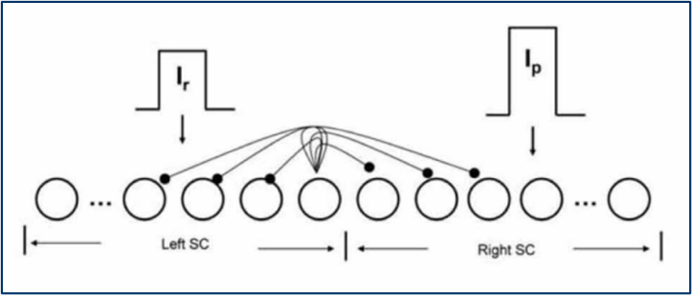

**Figure 1: The neural network model of the intermediate layer of the superior colliculus. There are 100 total nodes that are split in two halves. The left half represents the left superior colliculus, and contains nodes influenced by reactive input (Ir). The right half represents the right superior colliculus, and contains nodes influenced by planned input (Ip).**

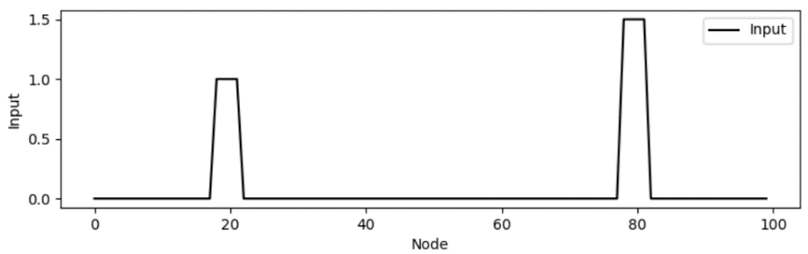

**Figure 2: Node 20 and its four nearest neighbors are influenced by the reactive input (Ir). Node 80 and its four nearest neighbors are influenced by the planned input (Ip). The planned input is 1.5 times more powerful than the reactive input.**

For each node, the internal state of each node in the network is governed by the following dynamical system:



Where the integration time constant is , the activation function is , the synaptic weights from node i to node j are governed by , the external input comes from *I*ext , and becomes either the reactive input *Ir* or planned input *Ip* depending on which side of the superior colliculus the node is on, and the background noise is governed by *In* . It’s also important to note that the left SC takes values from a normal distribution with mean μ1 and standard deviation σ1, while the right SC  takes values from a normal distribution with mean μ2 and standard deviation σ2.

The activation function is:



Where β is the steepness and θ is the offset of the sigmoid.

The synaptic weights  from node i to node j allow for lateral interactions between nodes in the same colliculus and between nodes in the opposite colliculus. The weights are chosen to be a shifted Gaussian distribution, and is positive for nearby nodes and negative for nodes in the opposite colliculus (Figures 3 and 4).



Where B and C are free parameters.

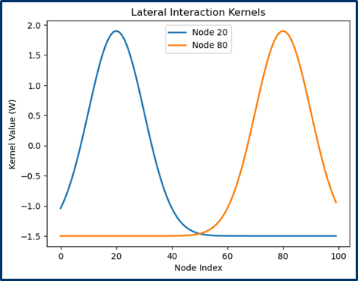

**Figure 3: The weights for node 20 are the most powerful for nodes around node 20 and become more negative as the distance increases. The weights for node 80 are the most powerful for nodes around node 80 and become more negative as the distance increases.**

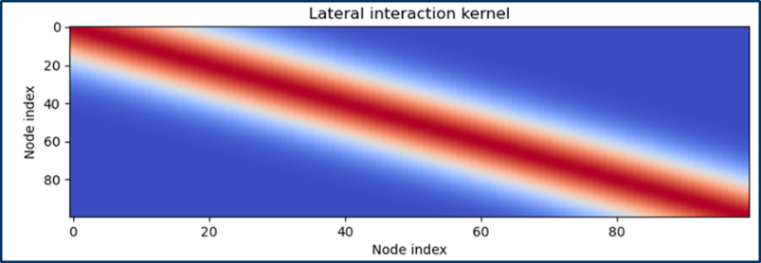

**Figure 4: The lateral interaction kernel. Positive for nearby nodes, negative for distant nodes.**

The reactive input is presented at t = 50 ms, and the planned input is presented at around 50 ms later. Both inputs remain active for ~600 ms.

The parameters come from the following table:

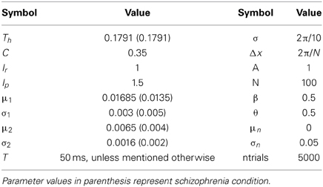

The implementation was done in Python (Jupyter Notebook). It was originally done in MATLAB 2009b. All reproduced code and graphs are original; No MATLAB code was translated to Python.

Mathematical Extension

To solve for the value of the state variable at time t, we want to find the solution to the above dynamical system.

To start, we divide both sides by the time integration constant, :

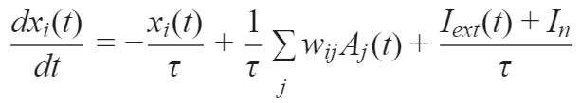

Next, we can introduce a new variable y(t):



Whose derivative then gives us:



We then get:  
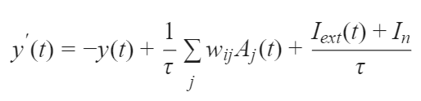

We then integrate both sides:  
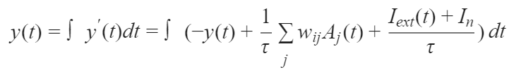  
  
So,  
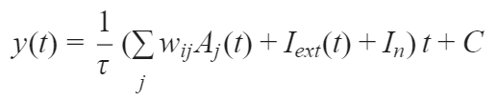  
  
Once we substitute y(t), we will get:

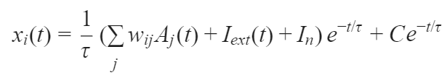  
  
We now have to find the constant of integration C. We will do this through the initial condition by setting t = 0:  
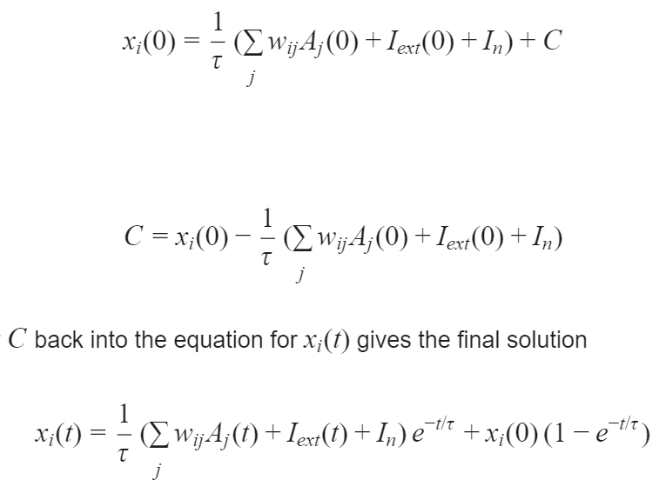  
  
We now solve for C:  
  
  
We substitute C back into our function, and we will get our final answer:  
  
Where 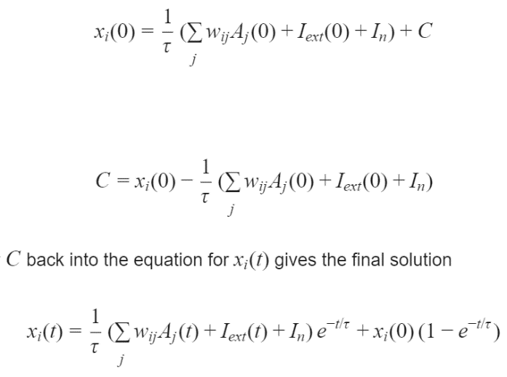 is the initial value.

Math equations were written in LaTeX for clarity.

Parkinson’s Disease and Multiple System Atrophy Extension

To further test the neural model, experimental data is used from a separate study by Brooks et. al (2017) that analyzes the antisaccade task performance for patients with Parkinson’s Disease and Multiple System Atrophy. Their study tested the two groups’ performance at two distinct time points: time point one being the first time the task performance is measured, and time point two being the same task performance test but 7 months later. The error rate (rate of error prosaccades) for PD patients was roughly the same at both time points, but the one for MSA patients increased substantially after 7 months. As for the latency distributions, the reaction times for PD patients dropped at time point two, but the reaction times for MSA patients was about the same.  
  
The results of the experimental data are represented in the following table:

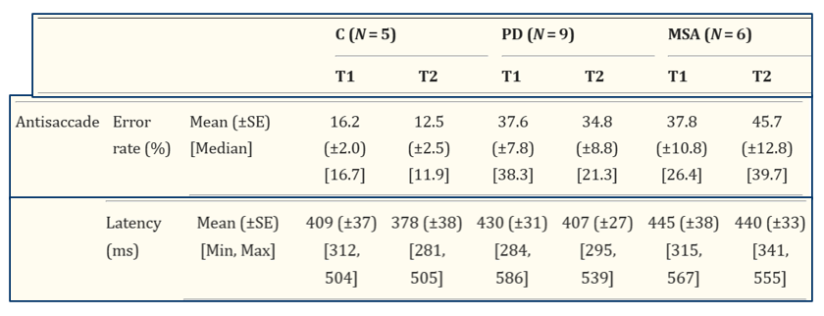

Where T1 represents the first time point, T2 represents the second time point, PD represents Parkinson’s Disease patients, and MSA represents Multiple System Atrophy patients.  
  
To test the performance of the model on this data set, the parameters were modified to fit the error rates and latency distributions. Specifically for the error rates: for Parkinson’s Disease, the standard deviation of the reactive input time integration constant was decreased (compared to the schizophrenia condition). The parameters did not change for T1 and T2 for the PD condition. For Multiple System Atrophy, the standard deviation of the planned input time integration constant was increased and the mean was decreased.

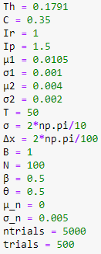  
**Figure 5: PD parameters for the time integration constants for both time points**  
  
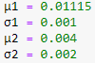  
**Figure 6: MSA Parameters for the time integrations constants for time point 1**  
  
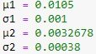  
**Figure 7: MSA Parameters for the time integration constants for time point 2**

**Results**

When we plot the dynamics for both groups, we notice predictability in the control group, but very high variability in the schizophrenia patient group (See Figures 8 and 9).

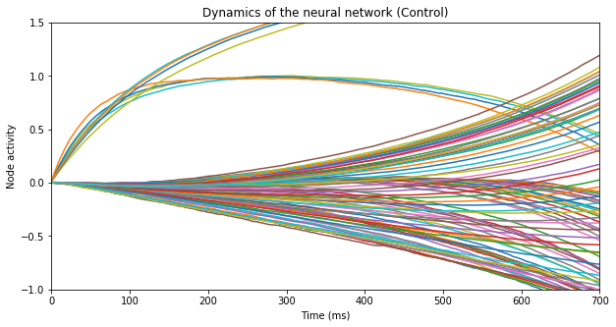  
**Figure 8: The dynamics of node activity for the control group.**

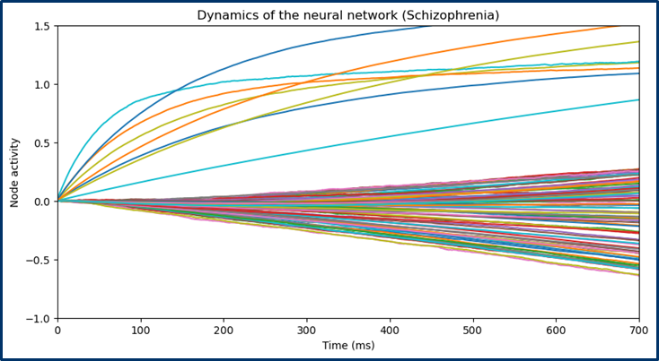  
**Figure 9: The dynamics of node activity for the patient group.**

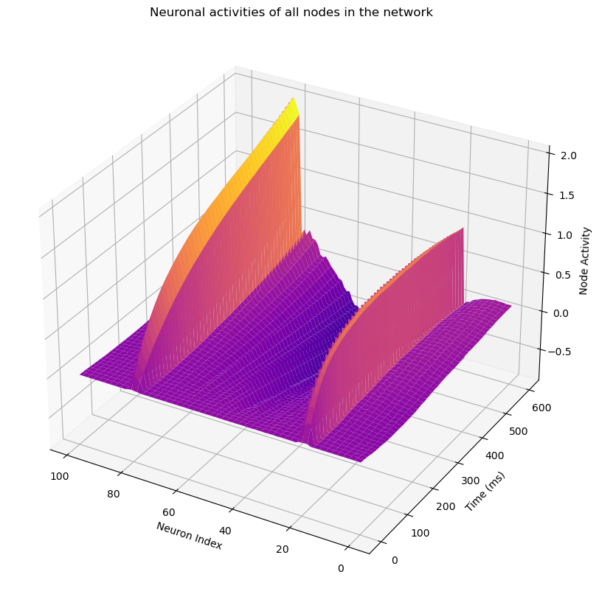  
**Figure 10: Neural activities of all nodes in the network as a function of time (ms)**

As mentioned previously, the planned input is more powerful than the reactive input, so we can see in the figure 8 that the nodes that have higher neural activity are the ones influenced by the planned input, while the nodes with weaker neural activity are the ones influenced by the reactive input. In the schizophrenia condition however, it is much more variable and difficult to tell which nodes are which. In other words, they are much noisier.

We can look at two individual trials from both groups to get a better understanding of how the model works. Because it is a neural rise-to-threshold model, there is some threshold, (*Th* ), that when reached by either node 20 or node 80, we will have either an error prosaccade or a correct antisaccade. There are cases where node 20 crosses the threshold, and soon after, node 80 crosses the threshold. In this case, there is an error prosaccade that was corrected into an antisaccade (See Figure 11).

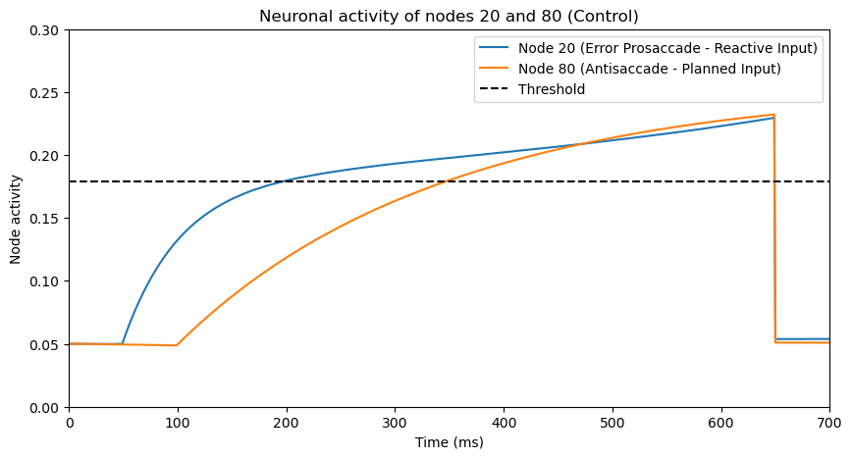

**Figure 11: One trial from a control participant. Node 20, influenced by reactive input, is activated at t = 50 ms, and node 80, influenced by planned input, is activated at t = 100 ms. Once either node reaches the threshold, which in this case is at 0.1791, a decision is made. In this case, an error prosaccade is followed by a correct antisaccade.**

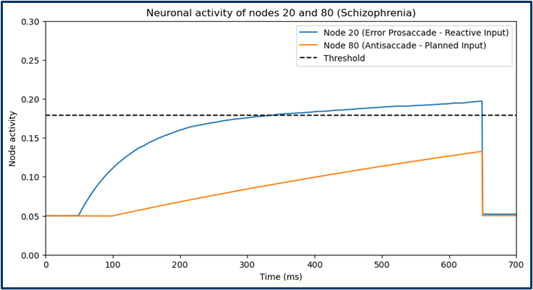

**Figure 12: One trial from a patient participant. Node 20, influenced by reactive input, is activated at t = 50 ms, and node 80, influenced by planned input, is activated at t = 100 ms. Once either node reaches the threshold, which in this case is at 0.1791, a decision is made. In this case, an error prosaccade is made without any correction.**

When we look at how the model performs at replicating the error rates and rates of error correction, the schizophrenia patient error rate is: 50.26% experimental, 51.10% model, while the control error rate is: 27.07% experimental, 14.10% model. Meanwhile, for the rate of error correction, the rate for the control group is: 93% experimental, 88.73% model, while the rate of the schizophrenia patient group is 86.53% experimental, 65.17% model. (See Figures 13, 14 and 15).

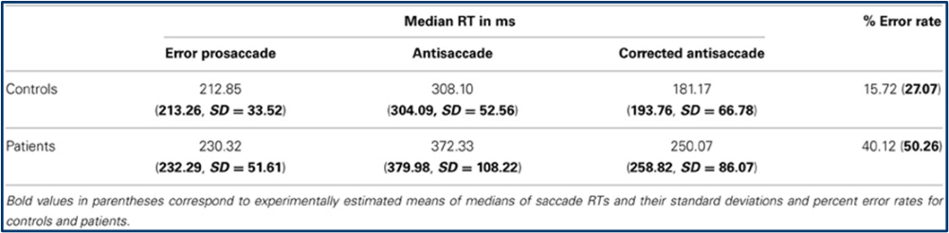  
**Figure 13: The median RT in MS and error rates for the control and patient group. The values in bold are the experimental data. The other values represent the values produced by the model from Cutsuridis et. al (2014).**

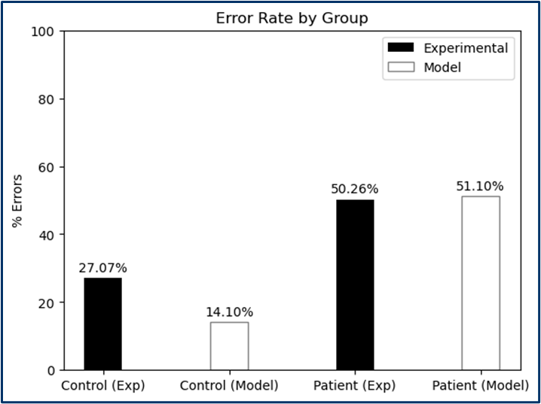  
**Figure 14: The error rate by group. Black bars represent the experimental data values, white bars represent the model values**  
  
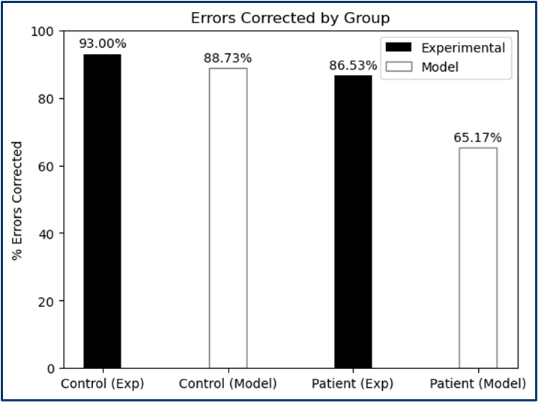  
**Figure 15: The rate of error correction by group. Black bars represent the experimental data values, white bars represent the model values.**

The latency distribution variations between the two groups were driven by the different mean and standard deviation inputs for each time integration constants .The mean was lower and standard deviation was higher for the schizophrenia condition (See Parameter Table Above).  
  
The latency distributions from the experimental values for the control group were 213.26 ms, 308.10 ms, and 181.17 ms for the error prosaccade, antisaccade, and corrected antisaccade RTs respectively. While for the schizophrenia patient group, the experimental values were 232.29 ms, 372.33 ms, and 250.07 ms for the error prosaccade, antisaccade, and corrected antisaccade RTs respectively.  
  
For latency distributions from the model values, the simulated median RTs for the control group were 214.0 ms, 306.0 ms, and 193.5 ms for the error prosaccade, antisaccade, and corrected antisaccade RTs respectively. For the schizophrenia patient group, the simulated median RTs were 226.5 ms, 367.0 ms, and 259.5 ms for the error prosaccade, antisaccade, and corrected antisaccade RTs respectively.

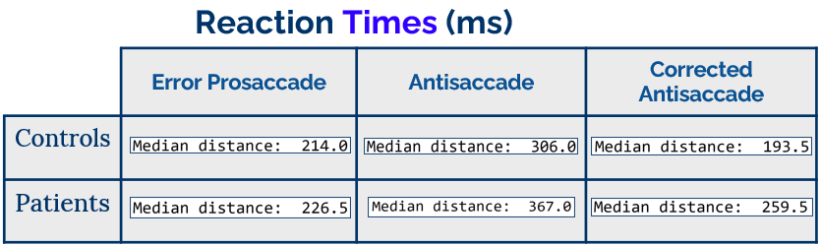  
**Figure 16: The model reaction times in ms**

As for the extension, the model accurately reproduced the experimentally tested error rates for both the PD and MSA groups. The error rates from the experimental values for PD were 37.6% (at T1) and 34.8% (at T2), while for MSA, the values were 37.6% (at T1) and 45.7% at (T2). Meanwhile, the error rates from the model values for PD were 35% (at T1) and 34.4% (at T2), while for MSA, the values were 37.8% (at T1) and 44% (at T2). (See Figures 17 & 18).

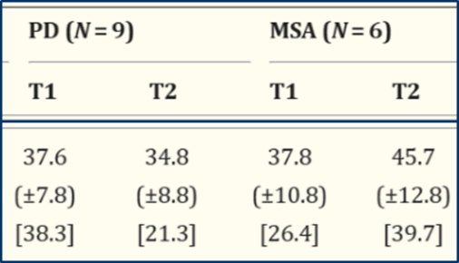  
**Figure 17: Experimentally values for the error rates of the PD and MSA group respectively**

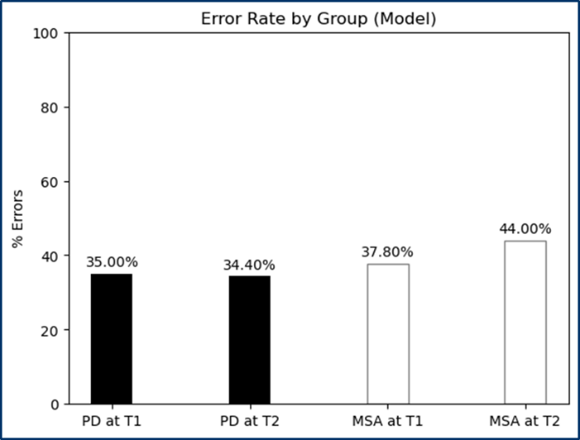  
**Figure 18: Error rates produced by the neural model**

When looking at the latency distributions, the experimentally tested values show a reaction time for the PD group a mean of 430 ms with a SD of 31 (at T1) and a mean of 407 ms and SD of 27 (at T2). For MSA, there is a mean reaction time of 445 ms and SD at 38 (at T1) and a mean of 440 ms and SD of 33 (at T2). (See Figure 19).  
  
As for the simulated latency distributions, the model produced for the PD group a mean of 430.36 ms and SD of 31.90 (at T1) and a mean of 408.73 ms and SD of 27.65 (at T2). For MSA, the model produced a mean of 445.72 ms and SD of 36.33 (at T1) and a mean of 440.59 ms and SD of 32.56 (at T2). (See Figure 20).

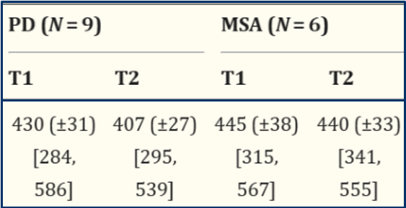  
**Figure 19: Experimentally tested latency distribution values from experimental data**  
  
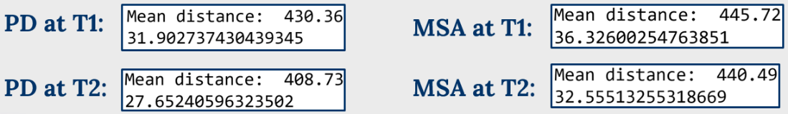  
**Figure 20: Simulated latency distribution values from model data**

**Conclusion**

When analyzing the antisaccade task performance, the neural rise-to-threshold model designed shows that the brains of schizophrenics tend to be noisier than those of the healthy control group. Moreover, when comparing the task performance of Parkinson’s Disease and Multiple System Atrophy patients, the brains of MSA patients become noisier after a period of 7 months, which makes sense given that MSA is a progressive neurodegenerative disorder that affects the body’s autonomic (involuntary) functions, including motor control. This noise is shown in the rate of information accumulation (from mean μ and standard deviation σ) rather than the threshold level or prior probability. Anatomically, a study by Lo and Wang (2006) shows that the decision threshold level could be set by the structures of the basal ganglia, and another study by Hutton and Ettinger (2006) suggests the poor performance in schizophrenics is due to basal ganglia disfunction. This model shows that the basal ganglia structures may be functioning normally, as the baseline level (threshold) is not being changed to fit the experimental data. Because the values for μ1 and μ2 are larger in the control condition than the patient condition, the latency distributions are slower for the patient condition, and because the values for σ1 and σ2 are smaller in the control condition than the patient condition, the variability for the schizophrenia condition is much higher. As mentioned earlier, these values manipulate the respective time integration constants for each side of the superior colliculus. Anatomically, these integration constants can be thought of as variability in the NMDA glutamate receptor activation, as NMDA hypofunction is shown to be implicated in schizophrenia (Lewis, 2012).

The model further shows that a third top-down inhibitory signal is not necessary to suppress the error prosaccades. The Noorani and Carpenter (2013) model that implemented a such third signal did not simulate the corrected antisaccades, while our model that does not have this signal did produce the corrected antisaccade latency distributions. The competitive neural network is evidence that competition between neurons encoding the error prosaccade and antisaccade is sufficient (in most trials) to prevent the error prosaccade from crossing the threshold when the antisaccade reached it first.

While the model accurately reproduced latency distributions, which is used as proof that a third inhibitory signal is not necessary, a major limitation of the study was the reproduction of error correction rates. From the experimental data comparing the schizophrenia and healthy group, we found that the controls corrected around 93% of their errors, while patients corrected 86.53%. However, from the model data, controls corrected around 88.73% of their errors, while patients corrected only 65.17% of their errors (See Figure 15 Above). An explanation as to why may come from failure to sufficiently activate the correct response, which then causes a failure to competitively inhibit the error prosaccade. This failure could be due to the increased variances of the Gaussian distributions from the integration time constants of error and correct node activities, therefore allowing slower antisaccade computations to take place that never reached the threshold within the 650 ms of simulation time.

Another limitation of the Cutsuridis et. al (2014) study comes from insufficient explanations as to why the parameters were chosen the way they were. For instance, the authors did not explain why the threshold they chose was at 0.1791. The authors did focus on the most important parameters, the mean and standard deviations used in the time integration constants, however for many of the other parameters, the explanations were either nonexistent or insufficient. Also, the authors did not provide the deviations for percentages for the error rates and rates of error correction, although the rates were different trial by trial.

In addition, the authors did their implementation in MATLAB, however provided no code to show their work. When emailing the corresponding author, Professor Vassilis Cutsuridis from the University of Lincoln, UK, I was informed that the code was no longer available.

As mentioned previously, all code is original, and there was no code translated from MATLAB, nor was any code taken from any public repositories. It’s possible that reproduction of the study’s results could’ve been simulated more accurately, or new insight would’ve been gained, had the authors published their code.

Overall, this model proved to be useful in showing quantitatively why the antisaccade task performance is so poor in patients with neurological disorders. This increased variability for those with schizophrenia, as well as poorer task performance after a 7-month time period for those with multiple system atrophy can be explained by a noisy accumulation of information before a decision is made. This model suggests that the threshold or confidence level does not have to be modified, and that the prior expectation does not affect performance. In addition, there doesn’t need to be a third top-down inhibitory control to get the desired results.

As a further analysis, it may be important to investigate the effects of age on the model. The schizophrenia patient group were ~10 years older on average than the control group, and based on a study by Olincy et. al (1997), we can see that the performance on the antisaccade task is impacted by age. This is a notable piece of information that can impact future research.

**References**

* Brooks, Sarah H et al. “Slowed Prosaccades and Increased Antisaccade Errors As a Potential Behavioral Biomarker of Multiple System Atrophy.” Frontiers in neurology vol. 8 261. 20 Jun. 2017, doi:10.3389/fneur.2017.00261
* Cutsuridis, Vassilis et al. “Antisaccade performance in schizophrenia: a neural model of decision making in the superior colliculus.” Frontiers in neuroscience vol. 8 13. 11 Feb. 2014, doi:10.3389/fnins.2014.00013
* Noorani, I, and R H S Carpenter. “Antisaccades as decisions: LATER model predicts latency distributions and error responses.” The European journal of neuroscience vol. 37,2 (2013): 330-8. doi:10.1111/ejn.12025
* Cutsuridis, V., Smyrnis, N., Evdokimidis, I., and Perantonis, S. (2007a). A neural model of decision making by the superior colliculus in an antisaccade task. Neural Netw. 20, 690–704. doi: 10.1016/j.neunet.2007.01.004
* Ann, Olincy., Randal, G., Ross., D.A, Youngd., Robert, Freedman. (1997). Age Diminishes Performance on an Antisaccade Eye Movement Task. Neurobiology of Aging, 18(5):483-489. doi: 10.1016/S0197-4580(97)00109-7
* Lo, C. C., and Wang, X. J. (2006). Cortico-basal ganglia circuit mechanism for a decision threshold in reaction time tasks. Nat. Neurosci. 9, 956–963. doi: 10.1038/nn1722
* Hutton, S. B., and Ettinger, U. (2006). The antisaccade task as a research tool in psychopathology: a critical review. Psychophysiology 43, 302–313. doi: 10.1111/j.1469-8986.2006.00403.x
* Lewis, D. A. (2012). Cortical circuit dysfunction and cognitive deficits in schizophrenia-implications for preemptive interventions. Eur. J. Neurosci. 35, 1871–1878. doi: 10.1111/j.1460-9568.2012.08156.x